1. **using IR led to make IR emit and receive system**

Components: A 5mm IR led, IR receiver: TSOP34338, Arduino 2560 R3, Cylinder crust, resister and wires

It is not necessary to add a lens in emit system, because IR led has already had similar structure.

**IR led : IR333-A**

Features

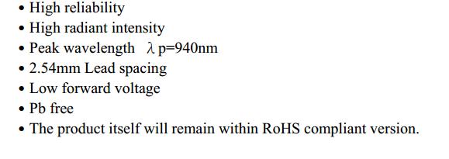

**IR receiver:** **TSOP34338**

Features:

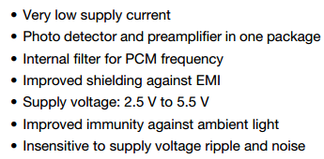

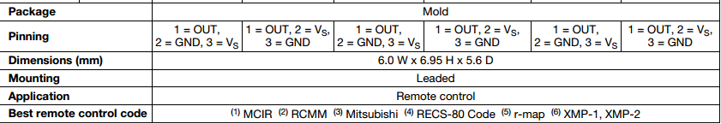

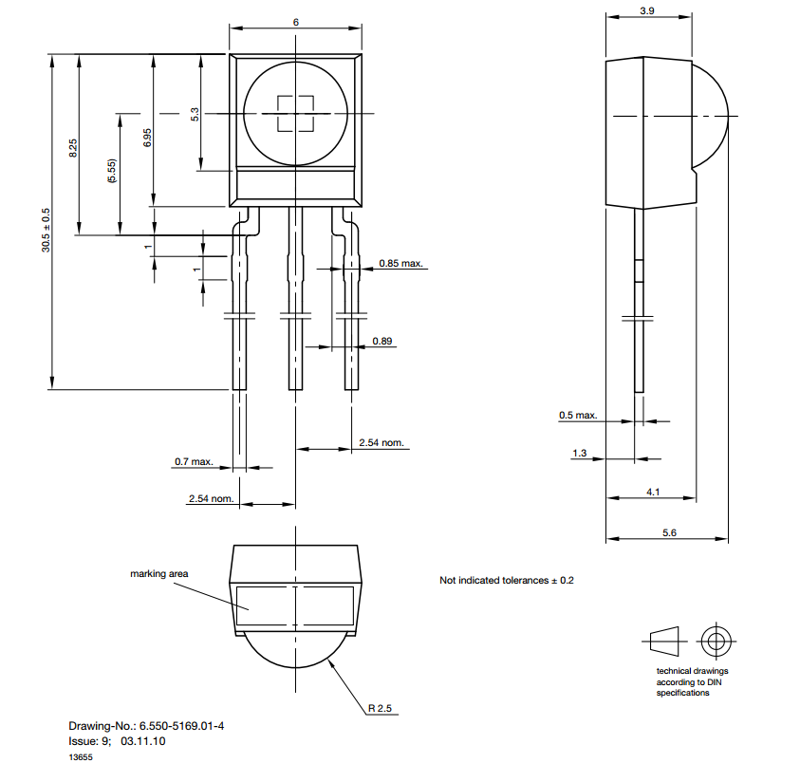

**Emitter:**

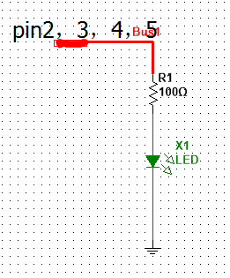

For the emitter side, we have to generate a carrier wave with 38 KHz. We decide to utilize PWM to generate carrier wave from the Arduino Microcontroller which is setting with 16 MHz working clock. Arduino board is supplied by 5v power and the maximum current of each pin is 40mA. The IR Led uses IR333-a, the maximum current in the output port is 20mA.

Depend on f=1/T=>38 KHz==>T=0.026us

What we get is that one period is 26us. Converting into digital signal is 1 for 13us delay and 0 for 13 us delay, and then repeat it forever.

In order to drive 4 sensors, we have to pick up four pairs of I/O ports: pin2 and pin 10, pin3 and pin11, pin4 and pin12, pin5 and pin 13

**Codes for generate wave with 38 KHz – initiatory version**

int IR_S1=2, IR_S2=3, IR_S3=4, IR_S4=5

void setup()

{

pinMode(IR_S, OUTPUT);

Serial.begin(9600);

}

void IR_Send38KHZ(int x)

{

for(int i=0;i<x;i++)

{

digitalWrite(IR_S1,1);

delayMicroseconds(13);

digitalWrite(IR_S1,0);

delayMicroseconds(13);

}

**Receiver side:**

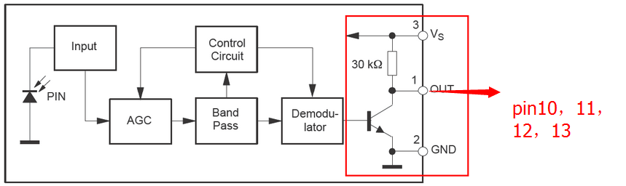

Design principal: when item go through the tunnel it will block the IR light, the state of receiver will change and we can get the responding signal from microcontroller.

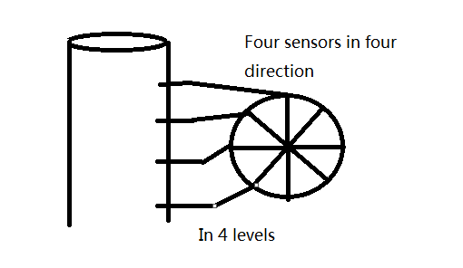

So, if sensor 1 or 2 or 3 or 4, any one of them detects the item the counter will get a trigger signal and then count one.

Consideration:

In order to detect item accurately, we have to consider using which way to send and to receive signal. The light from IR cannot gather into one point in our system. So, we need to consider the reflection of IR light and disturbing between each IR sensors. Therefore, taking example by IR remoter, we may choose to use IRRemote function library to add compiling signal on carrier wave if the result is unsatisfactory when use receiver to detect IR pulse signal.